NAMA : Nawang Indar Pratiwi

NIM : 20050974006

KELAS : PTI20B

1. 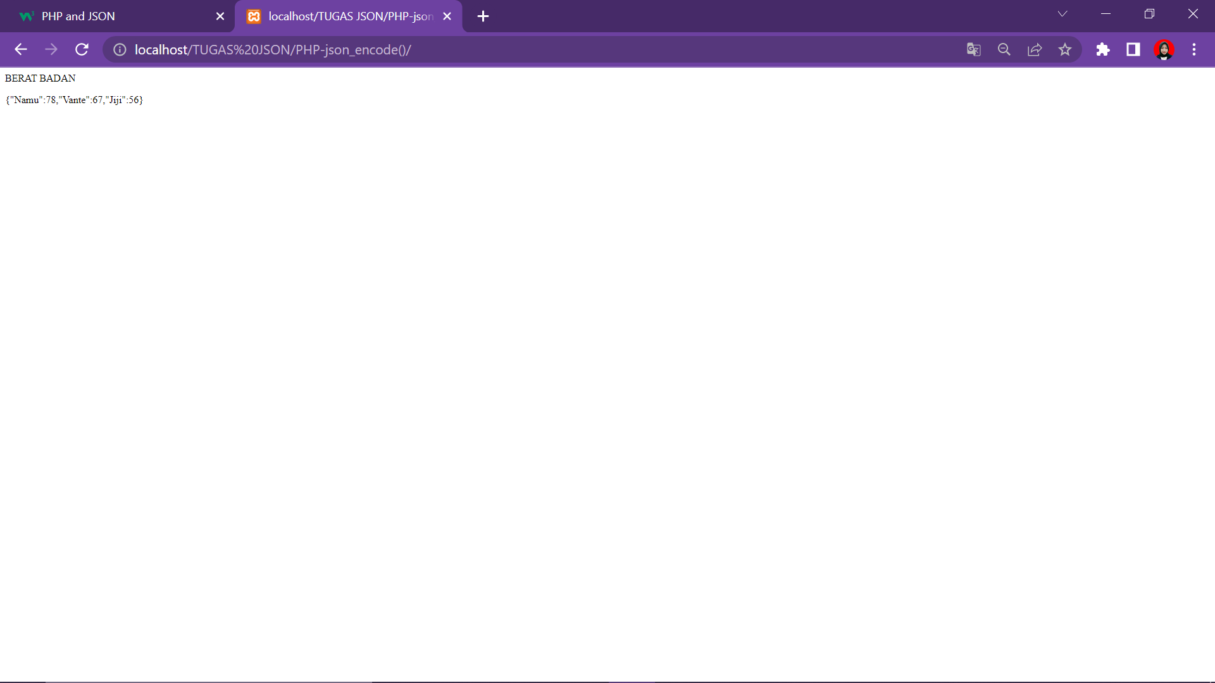PHP - JSON_ENCODE()
2. PHP - JSON_DECODE()

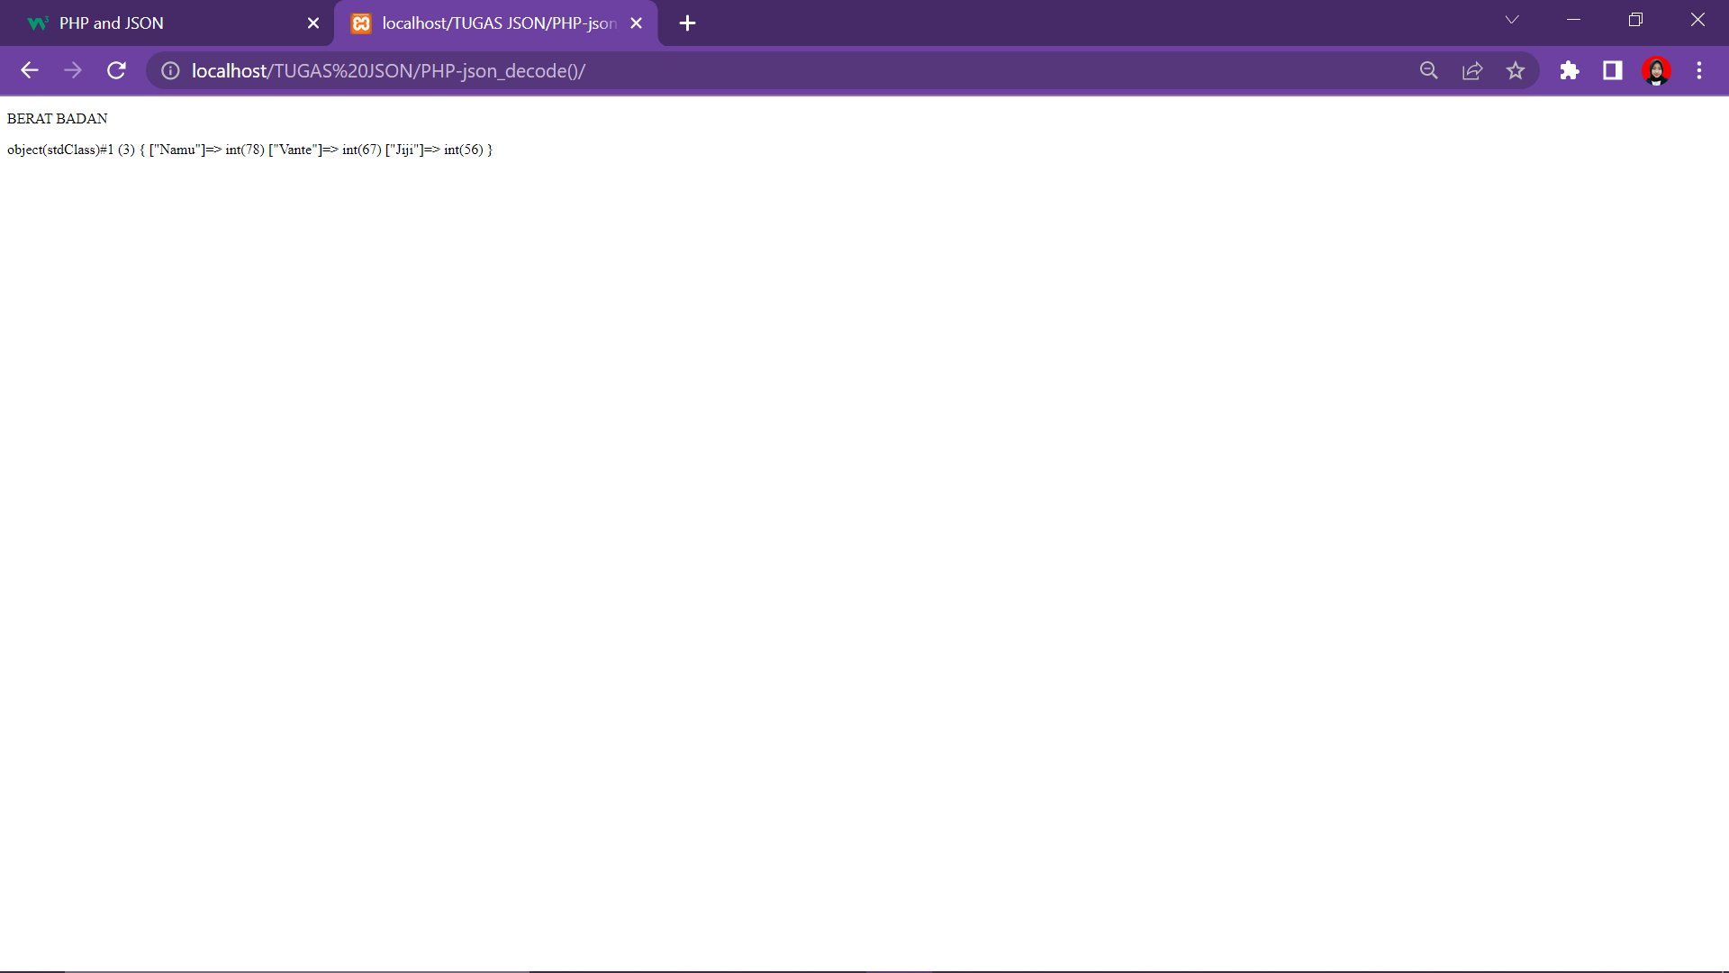

1. PHP - Accessing the Decoded Values

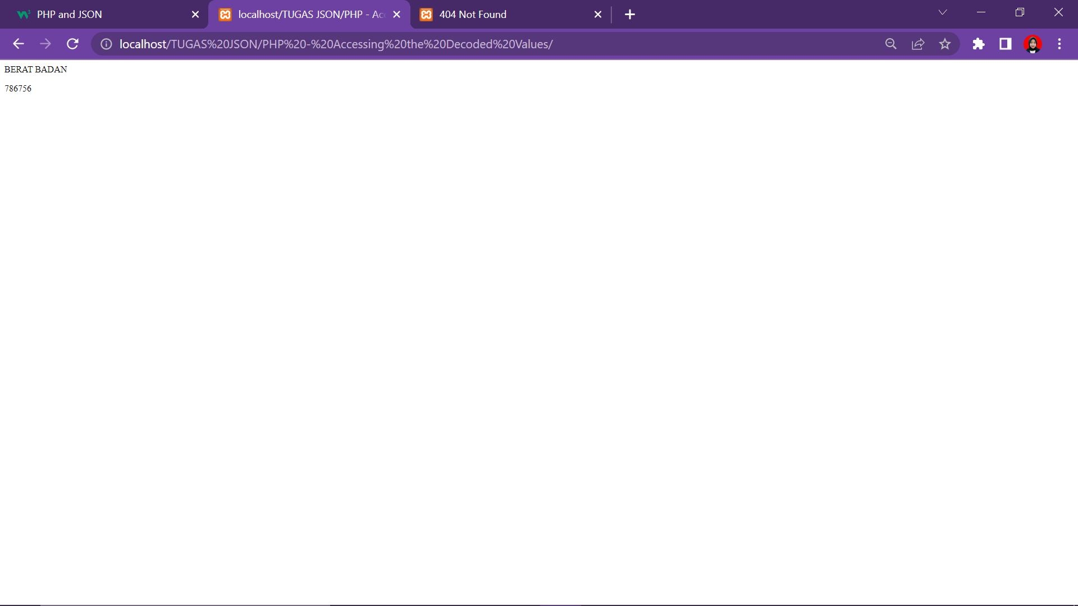

1. PHP - Looping Through the Values

